Practical No. 8

Name : Danish Altaf Solkar Class : CO - B
Enrolment no. : 24111590805 Batch : 2

Aim : Write a C / Python program to implement Banker’s Algorithm.

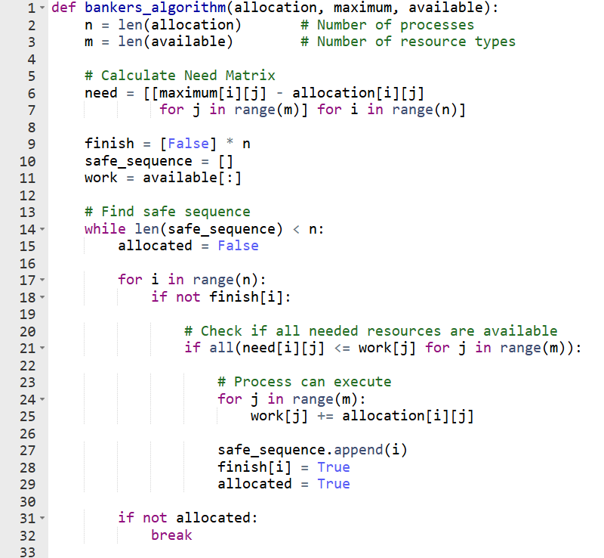

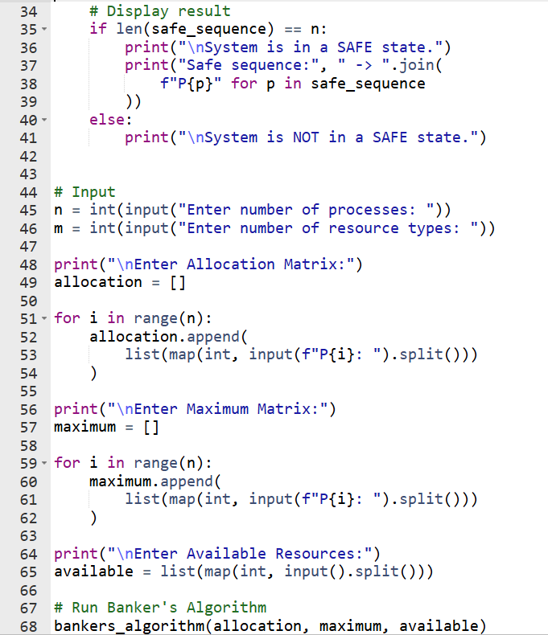

Output :-

